Assignment 7 ROS

Rafal Grasman

**Manual**

The goal in this assignment is to learn Behavior Based Robotics.

To use the package:

1. Extract the package into your catkin workspace
2. Follow the preparation steps of Assignment7.docx
3. Follow <http://wiki.ros.org/catkin/Tutorials/using_a_workspace> to build the package
4. roslaunch assignment7 assignment7.launch

Then use in another terminal that also has access to the catkin workspace:

**…**

To <…>

**Documentation**

**1**

The basic behavior of a robot could be turning away from a wall as demonstrated in the simulator:

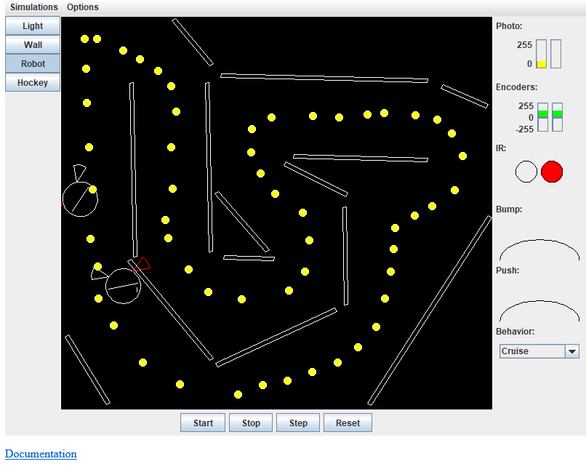

It is also possible to trigger different behaviors based on light and touch.

**2**

The files from mines-ros have been copied and used in assignment 7.

**2.1. Arbiter**

The arbiter has been made so that the current not-yet-published message is always the highest priority:

|  |
| --- |
| void Arbiter::velocityUpdate(const geometry_msgs::Twist::ConstPtr& cmd, int prio)  {  if (prio < priority)  {  priority = prio;  vel = *cmd;  }  } |

Then on tick it’s published and reset to lowest prio:

|  |
| --- |
| if (priority != velocities)  {  priority = velocities;  pub.publish(vel);  } |

**2.2. Seek Behavior**

The assignment3 follow_carrot has been used as seek_behavior because it’s ready to use code and can follow a line, and has been modified to accept PoseStamped instead of Goal/Path.